Happy Health Systems
Network Infrastructure Alignment and Virtualization Strategies
We will provide a centralize solutions for EMR and clinical applications
2015
[David Magnaterra]
3/16/2015

Table of Contents
Version Control 2
Executive Summary 3
Project Scope 4
Stakeholders 8
Project Requirements 8
1.1 Network EMR Topology w/Integration 12
1.2 Philips iSite PACS Topology 13
IP Addressing and Routing Architecture 13
1.3 Network Topology 14
Design and Rational 15
High Availability Plan 16
1.4 EMR Design 16
1.5 VM Architecture 18
Migration Plan 19
1.6 VM Conversions 20
Topology and Infrastructure 21
Presentation Virtualization 21
2.1 Server Design Model 22
Application Virtualization 22
Virtualization Roles, Integration, and Infrastructure 23
2.2 VDI Client Design Model 24
References 25

Version
Version Number | Deployment Model | Date
5.0 | U05A2 | 03/16/2015

Executive Summary
A need has become apparent for centralized data management and consolidation of applications. The goal is to create standardization across the network thus linking the sites and creating a scalable environment with low overhead. The server operating systems and SQL will be promoted to 2012 R2 versions at the Enterprise platform. Licensures for Microsoft, AIX and Linux will be evaluated for the best enterprise solution.
Domain controllers will be accessible by the network nodes upon orientation and business need. Windows Server 2012 R2 will become the standard for all Microsoft server nodes. Enterprise licensing for Windows Server 2012 R2 enables wide use of the new operating system moreover promoting virtualization and integration of new server roles and features. Window Deployment Services will be the vessel for server OS upgrades. This deployment will be systematic addressing domain controls first then DNS, SEP, and DHCP servers. All other application servers will inherit the new versions of the server OS after a database backup. Upon database servers being upgraded, the tables will be indexed to ensure a clean transition.
User workstations will have the option to select between multiple domains upon Active Directory user and group assignment. A DMZ (demilitarized zone) will host various virtual server environments thus providing efficient patient care for Physician and clinics.
The network circuits will be provided by Time Warner. Class C IP addressing will provide the scope the business requires. Various VLANs will identify the site of the Layer 3 switches; this type of switch will enable routing protocols for packet security. WAPS (wireless access points) will be installed at all sites for ease of access and patient contentment. The WAPs will have two channels, one for patient access and another for domain access.
Applications aligned with the standardized network infrastructure will enable seamless upgrades and administration. EPIC applications and derivatives, will liquidate many current applications for reporting. Secure access to the EMR and PACS will be delivered for effective and efficient patient care. Microsoft Office will be deployed to client nodes by Microsoft SCCM scripting. A report will be generated once the client nodes are joined to the domain. PeopleSoft ERP will be deployed from SCCM by group membership to the finance group. Once the user authenticates to the domain controller an unattended installation will be pushed to the user’s computer. Symantec security and Spybot Search and destroy will be encapsulated within the standard Windows 7 x64 image. SCCM imaging will occur by means of network PXE. The EPIC EMR Unix environment will be virtualized employing VMware vSphere 5.5. The interface engine Ensemble also will be a VMware node. Philips iSite, PathNet, PeopleSoft, Right Fax, and the domain controller in the DMZ incorporate Hyper-V virtualization.
Project Scope
Project summary and rationalization
Larry Macon, CFO of Happy Health Systems, called for the network and application alignment project to support cost with the business needs. Happy Health Systems is a network of hospitals and clinics located in southwest Ohio. We pride ourselves on accurate diagnosis derived by high technological means. A demand for secure confidential information access and sharing generates a new need for a topology change. Secure communication between sites will ensure compliance and data integrity. Patient information will inherit HIPPA compliant securities. The projected budgetary responsibility is 1.5.million dollars. Standardization strategically increases productivity and enhances patient care. The estimated annual support budget is $250,000 which will be drawn from the operational budget. Support is projected to become proficient for the IT systems served to the end users.
Project Overview
The undertaking of this project derives from a legacy support parameters and security constraints. The annual cost of legacy systems exceeds $300,000. Maintaining database updates will discontinue upon vendor support constrictions.
Project Charter
- Data traffic testing will begin with the current servers to gauge connectivity constraints.
- Volume estimates will be compiled and analyzed.
- Modality entries will be added (PACS).
- Physical nodes will be clustered for redundancy.
- Virtual nodes will utilize vMotion for redundancy.
- High availability servers will be placed at our disaster recovery site for another layer of redundancy.
- Security will be tested.
- Work flow changes will be defined for the department.
- Down time processes will be defined.
The scope of this project includes and excludes the following items:
Included
- Format: An Internet portal (Citrix) will provide the remote access point.
- Users: Will be provided Active Directory accounts.
- Users: Will be provided Exchange access.
- Users: Will be provided database access outside of LDAP (iSite, Cerner)
- Users: Will be provided EPIC securities.
- Users: A zero footprint viewer will be integrated into EPIC for access to PACS imaging.
- Update messages: Information regarding updates will be conveyed by email and the home page of the web portal.
- Infrastructure: Server remote upgrades.
- Infrastructure: Workstation remote upgrades.
- Infrastructure: Manual workstation hardware upgrade.
- Infrastructure: Manual workstation software upgrade.
- Infrastructure: Virtual host servers built.
- Infrastructure: VMware vSphere 5.5 integration
- Infrastructure: Windows 2012 Hyper Visor domain controller cloning.
- Security: All data pulled/pushed from the DMZ will be encrypted with 256 bit SSL.
- Search tools: The end user is provided searching and history features within EPIC, Cerner, and iSite.
- Internet: Access to the web hosted applications must comply with IE8 and IE9 browsers.
- Access: The web portal will be available 24 hours, 7 days a week.
- Support: The network support center will be available 24 hours, 7 days a week.
- Support: Each system will have an on-call administrator available 24 hours, 7 days a week.
Excluded
- Promotion: The web portal will not be promoted to other hospitals.
- Internet: Content and color schemes are not amendable.
- Email: The email usage will be internal Microsoft Exchange.
- Instructions: Instructions will be defined by the facility.
Approach
Sequential Processes
- Servers and clients will receive remote OS deployment
- Client workstations will be upgraded and imaged.
- A bi-directional tunnel will be established between clinic sites and servers.
- The physical servers will be clustered with a HA server (high availability) at a disaster recovery site with HP 3 PAR SAN alignment.
- The virtual servers will be redundant by vMotion with a HA server (high availability) at a disaster recovery site with HP 3 PAR SAN alignment.
- Data will be migrations will be completed after hours.
- Databases will be validated.
- The biomedical team will create new entries on all modalities (Radiology PACS) in the network.
- Dry run testing will begin.
- Upon success, the final go-live date will be determined.
- Network naming schemas and architectures will be standardized.

Cohesive planning and strategic implementation will enable a prudent outcome.
- Strengths: Critical thinking and well trained professionals will provide positive outcomes.
- Weaknesses The network bandwidth metrics will need to be analyzed or modified. Administration of systems will be transformed.
- Opportunities Aligning the applications and network resources will enable a scalable environment with low overhead. The upgrades and hardware administration will be managed by centralized support hence minimizing system diversification. Patient information will inherit added security therefore enhancing patient care.
- Threats The legacy systems may not be able to be fully tested parallel to the go-live. Workstations and print servers will be exchanged during the go-live.
- Risks Network failure could stop access. The redundancy will need to be assessed system by system.
- Constraints The budget will not stretch to fund unforeseen variables. The team is limited to six members. The timeline is smaller than other site’s metrics.
- Assumptions The appropriate tools are available. Each team member is competent in their role. The risk management has been analyzed accordingly. The ROI will exceed the initial investment.

Stakeholders
Name | Management Type | Role | Project Phase
Larry Macon | Capital Budget Allocation | CFO | Phase 1, 2
Dan Johnson | Applications | Manager | Phase 1, 2, 3, 4, 5
Bob Smith | Infrastructure | Manager | Phase 1, 2, 3, 4, 5
Lisa Connell | Clinical Informatics | Physician Liaison | Phase 4, 5
David Magnaterra | Clinical Applications | Trainer | Phase 3, 4, 5
Carl Canter | Infrastructure | Analyst | Phase 2, 3, 4, 5
Durral Kisone | Infrastructure | Workstation Lead | Phase 2, 3, 4, 5
Shane Wackson | Infrastructure | NOS | Phase 2, 3, 4, 5
Justin Walken | Infrastructure | Network Engineering | Phase 2, 3, 4, 5
Greg Courtney | Application | Analyst | Phase 2, 3, 4, 5
Dan Acape | Application | Analyst | Phase 2, 3, 4, 5
Larry Kiser | Application | Analyst | Phase 2, 3, 4, 5

Project Requirements
Process
The budgetary means equate to 55 million dollars capitol allocated for the project. The organization strategies include deployment by April 18, 2015. This is not a tentative date; the fiscal year must prove the EPCI EMR functions due to federal compensation and kickbacks. These kickbacks will negate cost thus enabling the new strategies to take form.
Organizational Assessment
Organizational constraints consist of data migration from the legacy Novell infrastructure. A single domain and forest will be executed for the new topology. Email migration from Novell GroupWise to Microsoft Exchange will occur and data validation will transpire as well. All DICOM data from the current databases will migrate to the Philips iSite IBM SAN. VCEs (virtual modules) will incorporate the structured DICOM datasets. A Vendor Neutral Archive (VNA) deployment will allow ownership, cost leverage, and DR capabilities for the proprietary iSyntex (compressed DICOM type) data. ACUO temporal routers will drop a copy on the Philips iSite SAN and the VNA thus providing the preceding capabilities illustrated in diagram 1.2. DNS and DHCP servers will be deployed at the four main facilities. A demilitarized zone (DMZ) will be constructed for remote access and public addressing. Lab datasets will migrate into the Cerner Pathnet Oracle database. Validation will occur upon migration. EPIC 2014 will become the EMR. All data from the prior Carecast EMR will be migrated into the EPIC environment. HL7 feeds will connect both Pathnet and iSite with EPIC illustrated in diagram 1.1.
Infrastructure assets range in operating systems. The current architecture consists of Windows Server 2000, 2003, and 2008. Windows Deployment Services will assist in server upgrades. Philips iSite and EPIC incorporate vendor owned hardware, these system comprise Windows platforms and UNIX architectures. These operating systems will not be a part of the deployment scope as they are supported by the vendor. Client workstations need hardware upgrades to facilitate the applications and the 64 bit upgrade. Moving from an x86 to an x64 platform allows larger use of memory for the workstations. Memory will be upgraded to expand performance. Virtualization of application server will occur for Cerner Pathnet and PeopleSoft. The two systems will become redundant with VMware vMotion technologies. A HP 3PAR SAN will be attached to all virtual nodes thus providing redundant storage with fiber channel bandwidth approaching 8 Gbps.
Requirement Management (multi-tier)
Network Administration
- Domain configurations consist of one domain with four domain controller one per hospital. Active Directory will entail user and group administration, DHCP, static IP scopes, site sub netting, DNS replication, and DFS sharing. Group policies will be deployed by SCCM as well as all unattended installer packages. (2/25/2015)
- Remote operating system deployment begins with servers which incorporate Windows Server 2008 or lower. Windows Deployment Services will deliver remote OS upgrades for servers and clients. Client must meet the following specifications to be in the WDS scope: dual core processor, 6 GB of RAM. Any client outside of the scope will be manually imaged by SCCM PXE distribution. (2/27/2015)
- Security will be managed by IPSEC technologies and SSL encryption. All non-LDAP databases will align security measures with standardized protocols. Users, network administrator, systems analyst, and domain administrator securities will be defined. Groups, organizational units and all other containers will be configured for centralize policy management. (3/2/2015)
- Email accounts migration into the Exchange platform will begin. Inbox storage allocation will be standardized. (3/10/2015)
- A parallel network will exist for testing; the current Novell network will coexist with the new Microsoft Server 2012 R2 Active Directory driven environment. After bi-directional connectivity is established, users and groups will be migrated. (3/10/2015)
- Network modifications will begin. The current existing routing and switch environment will be upgraded to a Layer 3 switch environment with F5 routing. (3/10/2015)
- Client Workstations will have to meet a specification of Intel E7600 2 core processors, HP 6000 pro workstations, 6 GB of RAM, Windows 7 x64, and IE 8 browser. (3/1/2015)
- Radiology Diagnostic Workstations will have to meet a specification of Intel Xeon E5620 4 core processors, HP Z800 workstations, 12 GB of RAM, Windows 7 x64, and IE 8 browser. Video will meet a specification of a Barco MXRT-7400 graphic card and a minimum of one Barco Coronis Fusion 6 MP MDCC-6130 monitor coupled with a minimum of one HP LA2405wg monitor. The standards will double the video specifications. (3/5/2015)
- Cutover and deployment will begin after business hours on a Friday. (4/18/2015)
Threshold -----------------------------------------------------------------------------------------------------------------------------
Application Administration
- EMR (EPIC) build will be compiled in the CER (test) environment. The design goals consist of HL7 interfaces, SUBI PACS integration, HIS management, Lab result GUIs (by HL7 messages), and PACS results GUIs (by HL7 messages). The integration engine delivering the HL7 messages will be an Ensemble integration engine. This will be the vessel for results and reporting. Groups and users will be linked to Active Directory by LDAP. Administration will be handled by the System Administrators. (4/1/2015)
- Philip iSite 3.6.150 will be the PACS. The archiving will have two DICOM stores. One store will be the SAN provided by Philips, the other store will be an Atmos VNA (vendor neutral archive) solution. The VNA will enable us to gauge the price per stored study with the vendor. Having and owning the information will provide variable leverage with the vendor. BSC (business continuity servers) will be placed at every main hospital for backup access to images these servers will be virtual. Temporal DICOM routers will live at every site for routing images to both iSite and the VNA. Groups and users will be linked to Active Directory by LDAP. Administration will be handled by the System Administrators. Results and reports will be interfaced by the Ensemble integration engine then made available to nurses and physicians. (4/10/2015)
- Cerner Pathnet will track dose and biopsy information. Groups and users will be linked to Active Directory by LDAP. Administration will be handled by the System Administrators. Cerner Pathnet will consist of two host servers carved into virtual servers. The HP 3PAR SAN will be attached to the nodes for redundant storage. Results and reports will be interfaced by the Ensemble integration engine then made available to nurses and physicians. (4/14/2015)
- PeopleSoft (virtual) will be queued to push by SCCM upon user authentication and user group membership. (4/14/2015)
- Workstations will be imaged and tested. The preconfigured systems will be deployed by a team of workstation administrators. (4/14/2015)
- Microsoft office will be deployed to all client workstations by SCCM. An inventory monitor script will run to monitor usage of the MS Office. If the product is not used in 90 days the suite will be uninstalled (a network pull by SCCM) to save enterprise licenses.(systematic upon 4/14/2015 WS deployment)
- Virtual servers will be built on a Physical server, upon proof of concept the systems then convert from physical to virtual.
Support
- Customer support models will be analyzed. The goal is to have application support teams, network engineering support, and network administration support 24 hours a day 365 days a year. (4/5/2015)
- Training will begin in a classroom atmosphere. Surveys will be delivered to the users. Additional onsite training will be available based on testing and feedback. (4/13//2015)
1.1 Network EMR Topology w/Integration
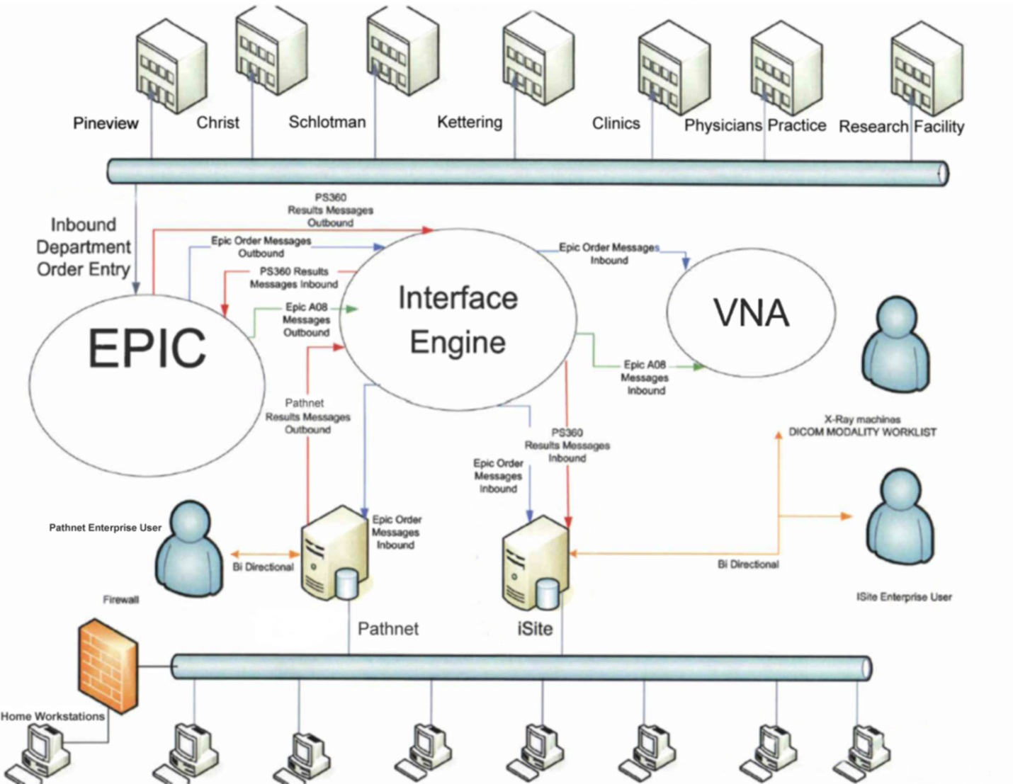

Radiologist will have preconfigured workstations sent to their homes. Access will connect by token and Cisco Any Connect interfacing. EPIC will not be integrated on these workstations. The Radiologist will need to access EPIC by token through the Citrix SAP. EPIC inherits many security updates thus negating VPN functionality due to constraints. These users will be in the standard VPN and SAP groups; iSite Enterprise and EPIC will also be advertised in the SAP for remote access.
1.2 Philips iSite PACS Topology
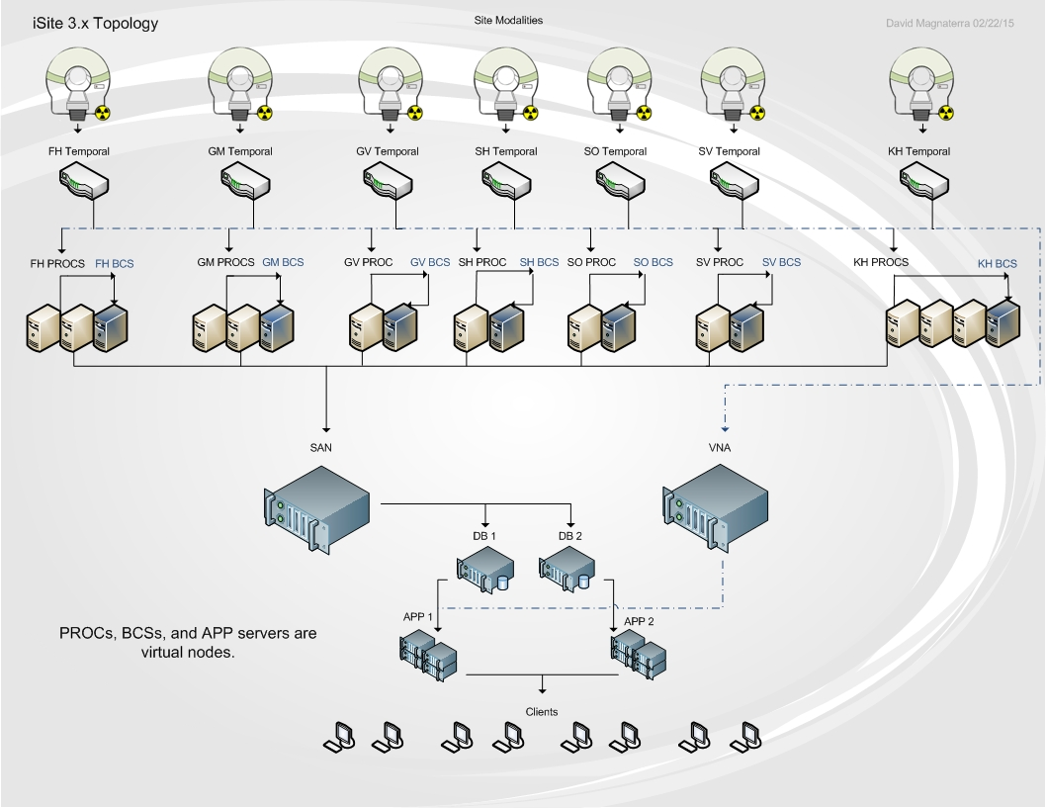
IP Addressing and Routing Architecture
IP addressing will comprise of a Class A scope and a Class C scope. The translation between the two networks will be done by NAT processes on the router. Replication between environments will take place across networks; this will ensure redundancy and enable separate physical networks thus safeguarding the network redundancy.
Clinics, Physician’s practices, and the research facility will apply VPN tunneling for access to the DMZ (demilitarized zone). The DMZ will incorporate iSite Enterprise, PathNet, PeopleSoft, and EPIC. This will enable secure access to the network applications, the Class A private network will NAT for communication to the public networks. The Servers will be added to the DMZ with IIS web hosting and account management. Illustration 1.3 displays the technical overview of the network. The four main hospitals will have two 1 Gbps fiber connections to the datacenter. One connection to the Class A network and one connection to the Class C network therefore providing redundancy. The F5 router will load balance between the two networks dependent upon bandwidth usage and peak hours.
1.3 Network Topology
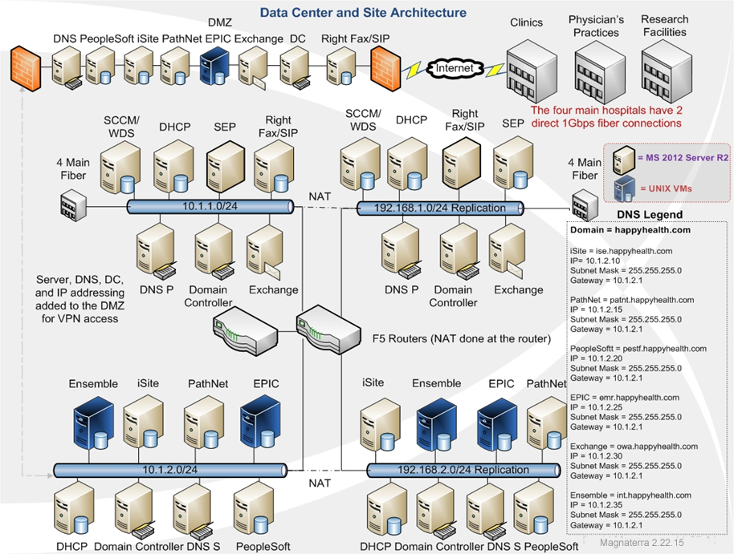
Design and Rational
Twelve host servers create the architecture for the virtual builds. The VMware ESXi hosts inherit eight of the twelve host servers at each datacenter. HP ProLiant DL380p G8 servers will be deployed incorporating Intel Xeon E7-2890 2.80 GHz processing combining dual socket CPUs with 15 cores for each socket. RAM resources expand 600 GB promoting effective resource allocations. Storage for virtual and physical clusters derived from the HP 3 PAR SAN located in the datacenter at Pineview and in the disaster recovery site as well. The nodes in the DMZ excluding the MS Exchange server and the DNS server will be virtualized for the branch offices to utilize. Exchange, DNS, SCCM/WDS, DHCP, and the other domain controllers will be physical nodes.
Moving to a virtual platform entails some risk yet the benefits out weight the perils. Virtualization allows the environment to negate physical clusters due to advanced migration features; vMotion allows the virtual nodes to migrate to another host server upon failure. This consent no down-time much like the fail-over features for a physical cluster. Security can become a major risk, the VCenter console manages all clusters thus creating a single point of failure to consider. Overall the migration features underline redundancy and are quite cost effective compared to physical clustering.
High Availability Plan
The EPIC EMR will utilize VMware vSphere 5.5 to encompass the virtual nodes for the EPIC system. The system backbone consists of UNIX and Cache married to Windows. The Cache database engine will run on UNIX divided by the various EPIC build environments. System mnemonics functions upon a UNIX and Cache platform in the following layers: POC, PLY, TST, and PROD. POC, TST, and PLY builds are segmented from PROD to ensure federation yet separate the environments. Figure 1.4 illustrates the model for deployment. Each module equates to a separate virtual server.
The virtual servers are replicated to the disaster recovery site moreover providing redundancy. Storage for the virtual machines derives from the HP 3 PAR SAN. All virtual servers reside between twelve host servers. The host servers can provide migration by means of vMotion. If a host server fails the virtual nodes simply migrated to a healthy host server negating service interruption thus generating an additional layer of redundancy. Each storage partition will be thin provisioned and live on a separate virtual SCSI adapter.
1.4 EMR Design
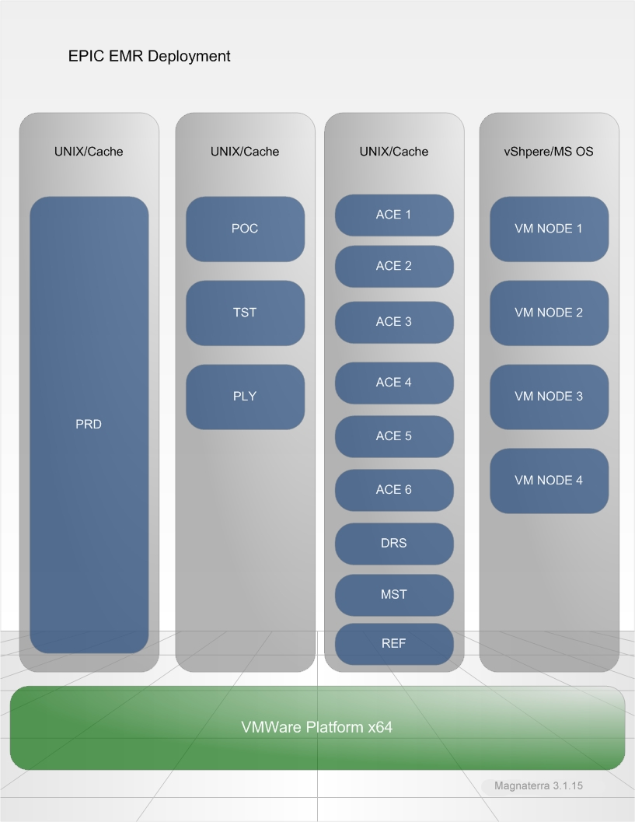
The marriage between Hyper-V, VMWare, Microsoft, Cache, and UNIX enables normalization between the multiple databases. Most database management will be driven by Windows clients therefore generating the portals for administration. Utilizing virtualization permits multiple layers of redundancy for the critical systems. High availability due to vMotion and disaster recovery alignment reinforces the architecture for both by redundancy and geographical diversity.
Driving these systems from the UNIX platform supplements low overhead and allows the environment to be scalable for the efficiencies associated to the file systems and the directory services. Hierarchy construction for data nodes directories allows associations. Replication between the main datacenter and the disaster recovery site will ensure high availability. Scheduled backups for the database servers are aligned with the best practices concerning the technologies. Multiple layers of redundancy will exist. The servers will have the data partition attached to the 3 PAR SAN which has a RAID and is replicated to the DR. The last layer involves Symantec Netbackups. All servers will have critical partitions replicated and stored for 30 days. In summation Microsoft SQL maintenance plans, SAN redundancy, and Netbackups will reinforce the architecture.
Maintenance plans will be created for all SQL databases they will incorporate back up processes, re-indexing, and housekeeping. These tasks will be scheduled for various times which are not during peak hours. SCCM resources will deploy and maintain application patches and profile settings. Software deployment will be executed as an unattended installer for version upgrades and new systems. Microsoft deployment for the clinics, Physician’s practices, and research facility will comprise of downstream WSUS servers as a parent child relationship with the upstream WSUS server. Replica mode between the upstream and downstream servers will enable synchronization and approval from the upstream WSUS server. The main upstream WSUS server will be located in the data center with a redundant counterpart on the class C network.
The virtual architecture comprises two techniques for high availability. The first concerns VMware. The VMware environment will have two VMH farms; one located in the datacenter and one located at the DR site. Each being a separate vCenter. EPIC and Ensemble reside in their own clusters. The Hyper-V nodes are simply split in two clusters and divided by instances conveying the second approach. Diagram 1.5 projects the architecture married to the SANs.
1.5 VM Architecture
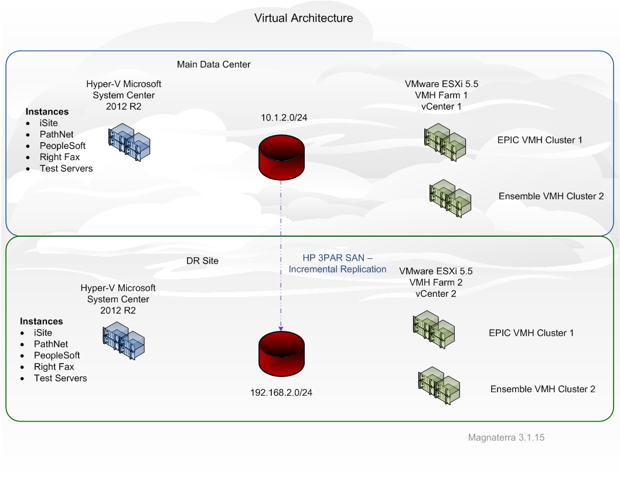
Tutorials collectively allow the fundamentals to be delivered concerning virtual machine placement and high availability design. Deployment of the design beings with conceptual prototyping. The context of the VM clusters first should be analyzed. The shared volumes need to be designed with failover clustering in mind. All SAN connections need to be validated prior to beta testing thus establishing the connectivity in the alpha stage. Failover functionality will be standardized by moving through the high availability wizard step by step, throughout the process the automatic start action should be modified to do noting when the machine is turned on. Each instance in will be on a separate SCSI controller following best practice regarding network configurations. Diagram 1.5 illustrates the clusters for the two virtual environments. The clusters are somewhat diversified. Hyper-V employs one cluster containing multiple instances whereas the VMware architecture utilizes separate clusters to effectively benefit from load balancing the F5 delivers.
Migration Plan
Migration for Happy Health Systems comprises both physical to virtual (P2V) virtual to virtual (V2V) conversions. We begin with the Philips product. Each site with a PROC (DICOM forwarder) and BCS (Business Continuity Server) will have two new physical host servers and a fiber channel array for cache. The legacy physical hardware will be built again on physical hardware with an updated OS and SQL. Upon executing multiple dry-runs, the two nodes will undergo a P2V. The local NTFS volumes will be copied by Virtual Machine Manager (VMM) and the Volume Shadow Copy Services (VSS) managed by VMM. After another round of testing a snapshot will be taken. The two new host servers will incorporate the standard functionality yet permit clustering for redundancy. A similar approach will be taken for PeopleSoft, Right Fax and PathNet. The main dissimilarity is these systems will live in the main datacenter. The second layer for iSite incorporates the APP servers and database servers. Staging will too occur for the P2Vs. Since there is two of each; proof of concept will be provided prior to virtualizing the sister nodes by means of V2V. After the snapshot for all Hyper-V P2V builds, the IP addresses will be changed to match the prior hardware, this will occur at the cutover. A single domain controller will be cloned for managing the DMZ; this process will allow the hosting of the PDC emulator moreover pulling the role from the source domain controller.
EPIC and Ensemble will be optimized from employing the VMware converter for P2V conversions. Both EPIC and Ensemble will be built and staged on physical hardware and VMware converter will be installed. Upon successful dry-run testing the conversion process will begin. The VMware stand alone will toggle the source servers (by IP address), the server database service will be stopped, and the powered on machine option will be designated. The new nodes will be defined in the ESX server, the VMSF data store and hardware version will be elected as well. After the conversion and testing, a snapshot will be taken. These ESX host will be managed in System Center 2012 VMM. All ESX virtual machines and adjoining services will be managed in VMM; this promotes a centralized scalable design. Diagram 1.6 exemplifies the design.
1.6 VM Conversions
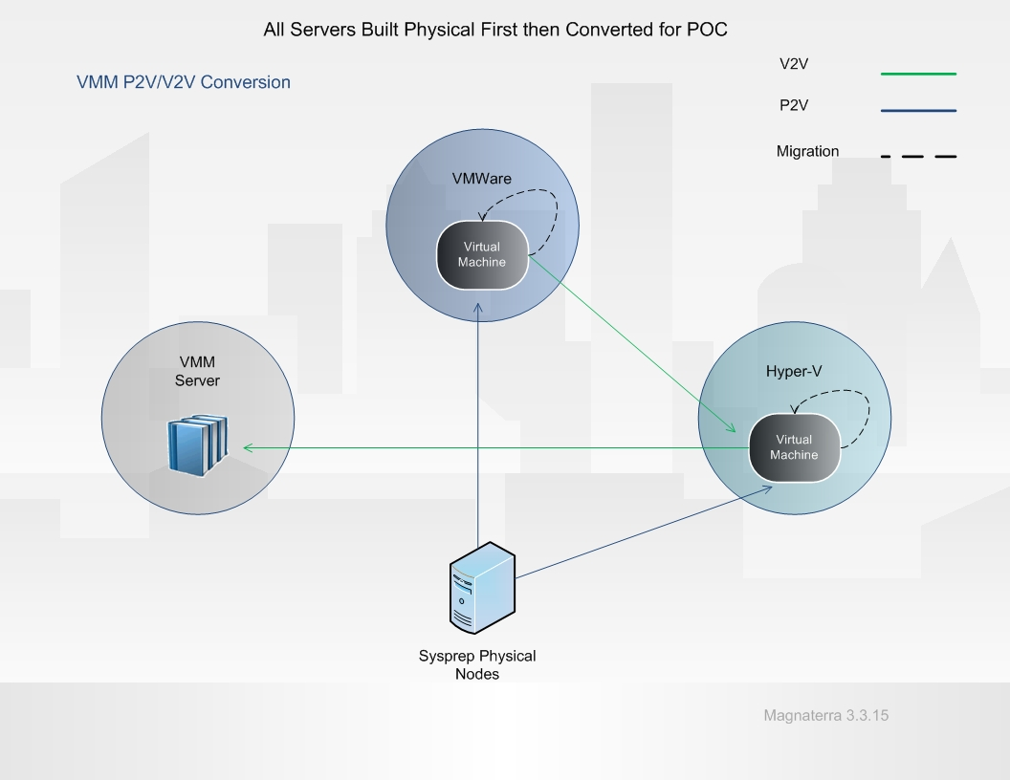

Topology and Infrastructure
The topology illustrated in diagram 1.6 denotes the handshake between services and virtual machines. V2V conversion travels from the VMware to the Hyper-V environments. This is cataloged with the VMM library. Operating system profiles, templates, and hardware profiles reside in the library for the two environments. The library server is considered a multiple library server and is highly available. Cluster’s instances are grouped in the library thus associating the server with the host nearby. Virtual networks are defined married to the physical networks. The subnets for the virtual nodes will have specific VLANs signifying the network type proving independence from the physical network. Overlapping IP addresses can be configured concerning migration, this may be an effective approach for balancing workloads. All storage for virtual machines are thin provisioned and built on a separate virtual SCSI adapter. These infrastructure configurations follow the best practices for implementation and future troubleshooting.
Presentation Virtualization
Happy Health Systems will virtualize the access points for remote users by employing a Citrix Independent Computing Architecture (ICA) married to Windows Remote Desktop Services (RDS). This is achieved buy advertising specific applications in the Citrix farm. RDS takes the place of the legacy Terminal Services, existent in the preceding architecture. Autonomous sessions ae now available with the new presentation thus allowing users to access the installed applications residing on the Windows 2012 Server operating system.
The Citrix functionality layers on top of RDS engaging the XenApp moreover adding enhanced capabilities to the RDS technology. ICA protocols allow load balancing, user logging, provisioning, and many other advancements for the environment. The presentation virtualization model is illustrated in table 2.1. Adding these features from Citrix on top of the RDS (within Windows 2012 Server) permits serving the application by group container management per user base. Policies are enforced from standard Active Directory Group Policy Objects (GPO) furthermore centralizing administration.
2.1 Server Design Model
EPIC | iSite | PathNet | PeopleSoft
VMware | Hyper-V | Hyper-V | Hyper-V
RDS/ICA Session | RDS/ICA Session | RDS/ICA Session | RDS/ICA Session
Windows 2012 Server R2 Operating System
EPIC VMH Cluster 1 | Hyper-V Cluster 1

Application Virtualization
Thin client delivery is the concept for the application virtualization. This functionality spans across browsers and devices due to the small footprint. The approach is to sequester each application by providing a dedicated virtual operating system for the client application. This negates clashes with concurrent systems and permits the associated hardware to be devoted to the application. In some cases the application will have virtual operating systems dedicated to services of one large application. EPIC (seen in diagram 1.4) segments its environments and services across multiple VMs thus optimizing the architecture by committing resources to specific components.
The EPIC virtualization is the largest task for application virtualization due to the vast array of modules and environments. The primary operating system for EPIC is a UNIX file systems are known as UFS (Berkeley Fast File System) which utilizes iNode (index node) to encapsulate Meta data for file description. The iNode defines a single file and can be considered somewhat obsolete. iNodes advancements consists of blocking by cylinder groups which separates the iNode data blocks into segments moreover negating fragmentation for large disk partitions.
Linux file system is ext2 (second extender file system) is known as a journaling file system and manages flash storage effectively. The ext2 file system is built from UFS concepts thus linking the technology between UNIX and Linux file systems. Linux provides access control list know as POSIX ACLs promoting scalable administration for system files. Ext2 is split into block much like UFS. They too are segmented into cylinder groups designed to minimize fragmentation. iNode integrates with the ACLs allowing the permissions to be applied to the blocked data. This will allow the environment to function as a virtualized application consequently transporting the UNIX architecture overlaid by Citrix as a roaming profile for the end users in a virtual desktop infrastructure (VDI).
Virtualization Roles, Integration, and Infrastructure
There are some requirements for presentation virtualization concerning software and hardware. Software sessions for user licenses must be analyzed prior to deployment. Operating systems compatibility and Citrix XenApp versions must be compliant as well. Citrix must have a licensing server for the application utilizing the XenApp 6.0 component; allocation can be defined in a scope pertaining to the application. Citrix XenApp 6.0 will need the session host plus licensing for remote desktop web access and remote desktop session broker distributed by licensing on the domain controller (in the DMZ). This negates any gateway configurations. Hardware allocations must be evaluated by vendor specifications; the provisions defined in diagram 1.5 determine the resources available for the various applications delivered by RDS and ICA.
Integration for the presentation virtualization comprises completely virtualized applications atypical to the standard application deployment models. Taking the host servers and farming processors, memory, and storage to application services and specific processes streamlines the availability of resources and allows the administrator to manage the allocation real time in most cases. Adding resources usually can occur without downtime furthermore minimizing the impact on the users and downstream systems. Integration can now take places in the desktop arena by conveying the same architecture yet delivered by VMware this is denoted in table 2.1 hence adjusting the operating system to emulate Microsoft Window 7 Enterprise Edition and employ HP Flexible Thin Clients (t520-GX) instead of the clustered host servers. These clients derive from a group of pools consisting of sessions for the VMware clients seen in table 2.2. Nightly scheduled reboots promote the session to be redistributed allowing effective updating.
2.2 VDI Client Design Model
VM Pool 1 | VM Pool 2 | VM Pool 3 | VM Pool 4
Active Directory Domain Controller
VMware Connection Broker
Windows 7 Enterprise VM – ESX Host
HP Flexible Thin Clients (t520-GX)

Each layer creates a handshake for the connection to the infrastructure. The session begins at the user interface within the thin client. The thin client login is delivered by a view administrator allowing the Windows 7 interface to interact with the VMware connection broker. The connection broker requests a remote desktop license from the domain controller and authenticates the user. Distributed File Systems (DFS) share logon scripting and application advertising occurs orchestrated by the association to the active directory group container. A session is drawn from a random pool transporting the full interface.

References
Microsoft.com. (2014). P2V: Converting Physical Computers to Virtual Machines in VMM. Retrieved February 22, 2015 from https://technet.microsoft.com/en-us/library/cc764232.aspx
Microsoft.com. (2015). Checklist: Configure Virtual Machines for Server Consolidation. Retrieved March 1, 2015 from https://technet.microsoft.com/en-us/library/cc771485.aspx
Microsoft.com. (2015). Supported Configurations. Retrieved March 8, 2015 from https://technet.microsoft.com/en-us/library/bb963738.aspx
VIRTUALIZATION. (2009). SC Magazine, 20(12), 58. Retrieved from http://search.proquest.com.library.capella.edu/docview/196346407?accountid=27965
VIRTUALIZATION. (2010). SC Magazine, 21(12), 50. Retrieved from http://search.proquest.com.library.capella.edu/docview/814864056?accountid=27965
Vmware.com (n.d.) VMware vCenter Converter Standalone Guide. Retrieved February 22, 2015 from http://www.vmware.com/pdf/convsa_50_guide.pdf

